** LEYTON SIXTH FORM COLLEGE – CENTRE NO: 13409**

**DEPARTMENT: COMPUTING AND IT**

**COURSE: BTEC EXTENDED DIPLOMA IN IT - ACADEMIC YEAR 2012-2013**

|  |  |  |  |  |  |  |  |
| --- | --- | --- | --- | --- | --- | --- | --- |
|  | | | | | | | |
| **Student Name: Student ID:** | | | | | | | |
|  | | | | | | | |
| **Unit No: 06 Unit Name: Software Design and Development**  **Internal Verifier: Date Verified:** | | | | | | | |
|  | | | | | | | |
| **Assignment No: # 2 of 3 Assignment Title: Designs and Implementations**  **Assignment Given Out: Assignment Submission Date:**  **Learning Outcome: LO3 Be able to use tools to demonstrate software designs.** | | | | | | | |
| **Task** | **Unit** | **Grading Criteria**  **Reference** | **Grading Criteria** | **Review Date** | **Grade Awarded** | **Date Achieved** | **Page No#** |
| 1 | 6 | P6 | Use appropriate tools to design a solution to a defined requirement. |  |  |  |  |
| 2 | 6 | M2 | Justify the choice of data types and software structures used in a design solution. |  |  |  |  |
| 3 | 6 | D2 | Develop algorithms to represent a design solution. |  |  |  |  |
| 4 | 6 | P5 | Explain the role of software design principles and software structures in the IT Systems Development Life Cycle |  |  |  |  |
|  |  |  |  |  |  |  |  |
| **Assignment Rules:**  Any work submitted after the deadline may not be marked. | | | | | | | |
| **Student declaration**  I declare that all of the work submitted for this assignment is my own work or, in the case of group work, the work of myself and the other members of the group in which l have worked has not been copied from any source. I understand that if any part of the work submitted for this assignment is found to be plagiarised, none of the work submitted will be allowed to count towards the assessment of the assignment.  **Student Signature: Date:**  **Assessor Signature: Date**: | | | | | | | |

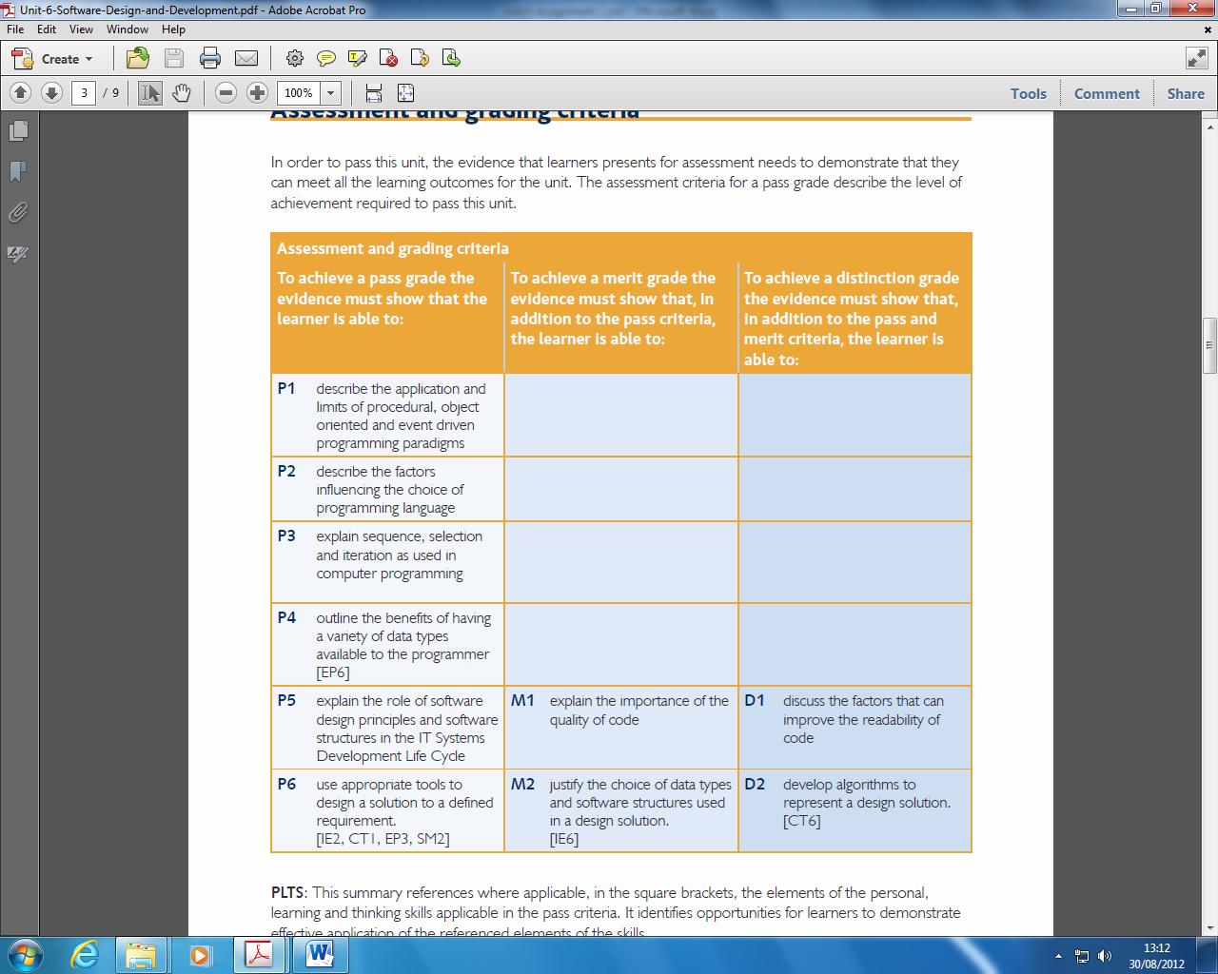

|  |  |  |
| --- | --- | --- |
| **Criteria Reference** | **Learning outcome/evidence (Candidate should be able to produce)** | **Completed** |
| P5 | P5 explain the role of software design principles and software structures in the  IT Systems Development Life Cycle |  |
| P6 | P6 use appropriate tools to design a solution to a defined requirement. |  |
| M2 | M2 justify the choice of data types and software structures used in a design solution. |  |
| D2 | D2 develop algorithms to represent a design solution. |  |

# Assignment Brief:

**Task scenario A**

*You are a trainee programmer and have been requested to show your abilities by constructing a program for the following payroll task:*

* Accept as input data the four items EmployeeNumber, EmployeeName, HoursWorked and HourlyRate for a single employee
* Calculate the GrossPay, which is the HoursWorked times the HourlyRate
* Calculate Tax which is levied at 20% of the GrossPay
* Calculate NI which is levied at 10% of the GrossPay
* Calculate the NetPay which is the GrossPay less Tax and NI
* Display the resulting Payslip in a professional style.

Tasks:

1. Analyse the above and list the requirements of this problem.
2. Design (i) a plan for the program in pseudo-code or flowchart form, and (ii) the layout of the input requests and the output payslip. **(P6)**
3. Investigate the types of variables commonly used in Pascal or Visual Basic programs and choose suitable variable names and data types for the values you wish to refer to in your program.

Explain why you consider the chosen data types to be appropriate. **(M2)**

Write the program, remembering to annotate your code with suitable comments showing how input, processing and output is handled here.

1. Explain how your program satisfies the requirements of task 1.

**Task scenario B**

*The rules are changed and you have to perform some adaptive maintenance.*

Assume that employees **under 18 are exempt from paying tax and NI contributions.**

**Other employees only get charged the 20% tax and 10% NI rates on earnings over £100.**

Tasks:

1. Revise your answer to task 2 to include this change.
2. Show how you would use IF or IF ELSE statements to effect the change in deductions

**Task Scenario C**

The program needs to work for more than one employee.

Tasks:

1. Show how you would use the FOR statement to process the wages of three employees.
2. Show how you would use the Repeat/Until or While/Do constructs to make the program work for many employees.
3. Totals for the GrossPay, Tax, NI and NetPay for all employees are required.

Show how you would accumulate these totals in the employee processing loop and design and implement a suitable layout for the display of these totals after the last employee has been processed.

1. The wage details for each employee need to be stored in a text file for future reference.
2. Revise your answer to Task 6 to include these changes

**Task Scenario D**

*BUGS! The Boss notices that the program fails when non-numeric data is entered for a numeric value.*

Tasks:

1. Show how you would trap erroneous data using the REPEAT/UNTIL mechanism.
2. The Boss decides that nobody works more than 40 hours a week and that nobody gets paid more than £20.00 per hour. Show how you would validate data so that any values outside these limits are rejected.

1. The Boss thinks that the program is getting too large and unreadable, despite all of the comments that you have added. He thinks that the program structure will be improved by creating separate functions for clearly defined tasks – for example

* Enter and validate the hours worked
* Enter and validate the hourly rate
* Perform the tax and NI calculations
* Add to the overall totals
* Assemble the data to be written to the text file.

Simplify the form of the program by adding these procedures, and then calling them from the main program.

You may have to be careful in declaring the variables locally or globally.

1. Revise your answer to Task 12 to include these changes.

List your final fully annotated program and include a testing section to ensure that all program code functions correctly.

Create a user and a technical guide.

Recheck that all tasks have been addressed, and get two colleagues to review your work.

If there are any omissions or sensible suggestions revise your final program.

Evaluate your work and suggest potential further extensions. **(D2)**

1. Explain through a diagram and further explanation the stages of the systems life cycle applied to software development and show how you have followed this cycle in the previous tasks 1-15 (**P5)**